372857 Lower Granite Juvenile Fish Facility
CRFM Work Plan - January 2018
1. Project Information
- Purpose/Objective. Improve/Upgrade Juvenile Fish Passage in Lower Granite Dam including; larger 14” diameter orifices, daylight flume, enhance PIT TAG detection, improved JFF water supply, enhanced adult ladder attraction water, emergency bypass option, and new outfall located to improve direct and indirect survival of collected and bypassed fish.
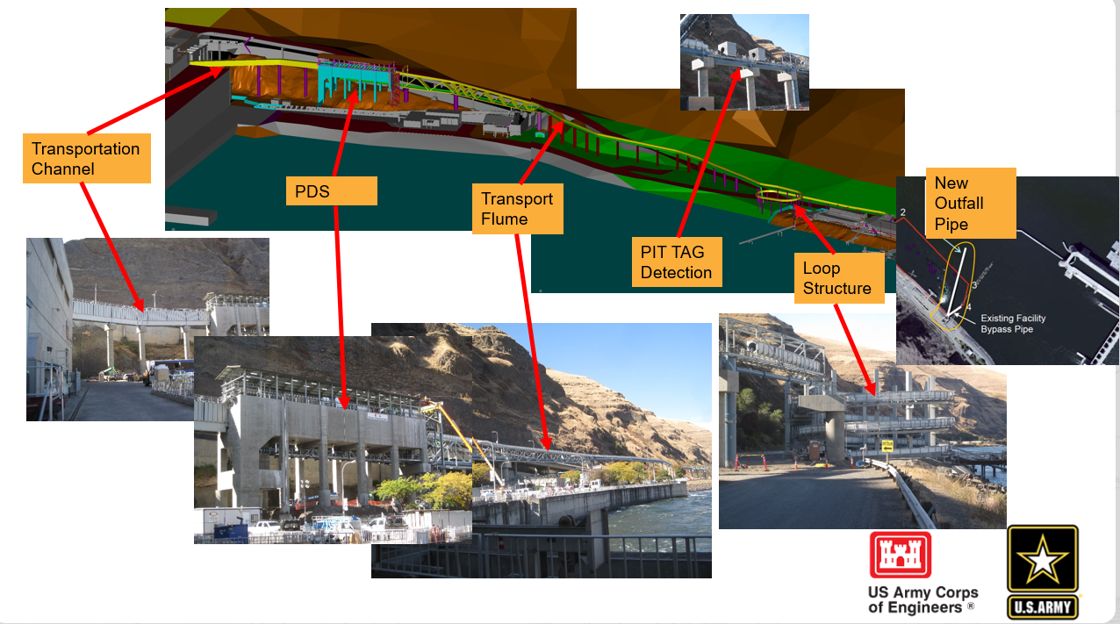Description. The project is located at Lower Granite Lock and Dam. Phase 1A daylights the juvenile fish transportation piping from the dam to the juvenile fish facility, Major components are enlarged collection channel orifices to 14 inch dia., widened collection channel to 9.5 feet, upper and lower concrete plugs in the reservoir side fish slots, dewatering structure, above ground flume, flume switch gate, secondary dewatering unit, and emergency outfall. Phase 1B provides a new outfall location for a primary bypass which bypasses the juvenile fish facility via the switch gate.
2. Major Activities/Tasks.
FY18 – Full Fish passage through the system is scheduled for no later than Mid-April. FY18 funds will be utilize to physically complete and commission of Collection channel, Primary dewatering structure (PDS), Transport flume, Pit detectors, Loop structure, New outfall pipe. Approximately $5M is being used to complete all the necessary modifications due to unforeseen conditions and design flaws.
FY19 –Completion of all landscaping and paving work. Completion of automated orifices. Known unknowns such as safety and security items will be addressed during the close out.
3. Cost Estimate.
FY 17 Final Obligations $12,418,444
FY18 Budget - $9.3M
4. Information and Issues.
Project is marked as priority and it is under close monitoring for schedule and cost

